**SOFTWARE REQUIREMENT SPECIFICATIONS (SRS) DOCUMENT**

**NAME**: THANUSHRI N

**ROLL NO**: 7376222AL215

**YEAR**: II

**DEPARTMENT**: AIML

**PROJECT ID**: 23

**SEAT NO:**23

**PROJECT TITLE:**

“Approval of On-duty for the students”

**TECH STACK**: MERN

**PROBLEM STATEMENT:**

In our college, students often need to request on-duty for various reasons such as attending technical and non-technical events. However, it's crucial to ensure that students maintain a balance in their academic and obtain necessary permissions:

1. **Manual, Time-Consuming Process**: Currently, approving on-duty requests in the college involves a manual process that consumes significant time and effort. Each request needs to be handled individually, leading to delays in processing. Faculty members and staff may need to physically review and sign off on paper forms or manage requests through emails, resulting in inefficiencies and potential delays in response times.
2. **Lack of Centralized System:** There is no centralized system in place to manage on-duty requests, causing further delays and errors. Without a unified platform, requests may get lost or overlooked, leading to inconsistency in approval procedures. Moreover, the absence of a centralized database makes it difficult to track the status of requests or maintain a comprehensive record of approvals and rejections. This lack of coordination can result in errors, miscommunication, and frustration among stakeholders.

**SOLUTION:**

By implementing a centralized on-duty approval system with automated workflows, real-time notifications, and role-based access control, the college can overcome the challenges of manual processes and lack of centralization, leading to improved efficiency, accuracy, and satisfaction among stakeholders (Special Lab In charge, Parent, Mentor).

**Software Requirement Specifications (SRS):**

1. **Introduction:**

The On-Duty Approval System is a web-based application developed to automate and streamline the process of approving on-duty requests for students in the college. This document outlines the requirements and specifications for the development of the system.

1. **Scope:**

The system will automate the approval workflow for on-duty requests, including verifying academic and placement faculty advisor approvals, special lab in charge verification of event details, parental acknowledgment via automated calls, and final approval by the mentor. It will provide notifications and updates to stakeholders and maintain a comprehensive record of all approvals.

1. **INDENTED AUDIENCE AND USE:**

This portal is designed for two primary users:

* **Students:** The primary audience, who will initiate on-duty requests through their mentors or directly. They will use the system to provide event details and track the status of their requests.
* **Faculty Members**: Including academic and placement faculty advisors, as well as special lab in charge. They will review and approve on-duty requests, ensuring compliance with academic and event-related requirements

1. **SYSTEM FLOW:**

**System Flow for Public Access (Students):**

1. **Login:**

* Students will log in with their secure credentials (email and password) provided by the college.
* Upon successful authentication, they will be directed to the dashboard.

1. **Dashboard:**

* Students will have access to a user-friendly dashboard with the following sections:

a. **Submit On-Duty Request**: Students can initiate on-duty requests through this section, providing event details such as date, time, event, and any additional information required.

b. **Track Request Status**: A section displaying the status of their on-duty requests, including pending, approved, or rejected. They can view details of each request, including approval status and any comments from faculty or mentors.

c. **View Event Details**: Students can view event details for approved on-duty requests, including location, date, time, and purpose.

d. **Profile Information**: Basic profile information such as name, contact details and academic details.

1. Submit On-Duty Request Form:

* When a student initiates an on-duty request, they will fill out a form providing event details such as date, time, purpose, etc.
* The submit button on the form will be enabled only if the academic (FA) percentage is above 50% and if the placement (FA) percentage is above 50%.
* The system will check the student's academic performance from the database and enable/disable the submit button accordingly.

1. **Form Submission:**

* Once the student fills out the form and ensures that the FA percentage is above 50%, they can submit the on-duty request.
* The submitted request will be stored in the system and forwarded for further processing.

1. **Request Tracking:**

* After submission, the student can track the status of their on-duty request through the dashboard.
* They will receive updates on the approval process, including notifications when the request is approved, rejected, or pending.

**System Flow for Protected Access (Faculty - Special Lab In charge):**

1. **Login:**

* Special lab in charge will log in with their secure credentials (email and password) provided by the college.
* Upon successful authentication, they will be directed to the dashboard.

1. **Dashboard:**

* Special lab in charge will have access to a dashboard with the following sections:

a. **View On-Duty Requests**: Only on-duty requests submitted by students associated with the special lab in charge’s lab code will be displayed.

b. **Verify Event Details**: Special lab in charge can view event details for each request, including location, date, time, purpose, and any additional information provided by the student.

c. **Approve or Reject Requests**: Special lab in charge can approve or reject on-duty requests after verifying event details. They can provide comments or additional instructions if needed.

1. **Automatic Notification to Parent:**

* After special lab in charge approval, the system will automatically retrieve the parent's contact number from the student's profile.
* An automated notification (e.g., SMS, email or call) will be sent to the parent informing them of the on-duty request and prompting them for approval.

1. **Parental Approval:**

* Upon receiving the notification, the parent can acknowledge the on-duty request.
* The system will wait for parental approval before proceeding further.

**System Flow for Protected Access (Faculty - Mentor):**

1. **Login:**

* Mentor will log in with their secure credentials (email and password) provided by the college.
* Upon successful authentication, they will be directed to the dashboard.

1. **Dashboard:**

* Mentor will have access to a dashboard with the following sections:

a. **View Assigned Students**: Only students assigned to the mentor through their mentor code will be displayed.

b. **Verify Details**: Mentor can view each detail about the event, special lab in charge approval and the parent approval.

c. **Initiate On-Duty Requests**: Mentor can initiate on-duty requests on behalf of assigned students, providing necessary event details and submitting the request for approval.

1. **TECHNICAL COMPONNENTS:**

**MERN – MongoDB ExpressJS ReactJS NodeJS**

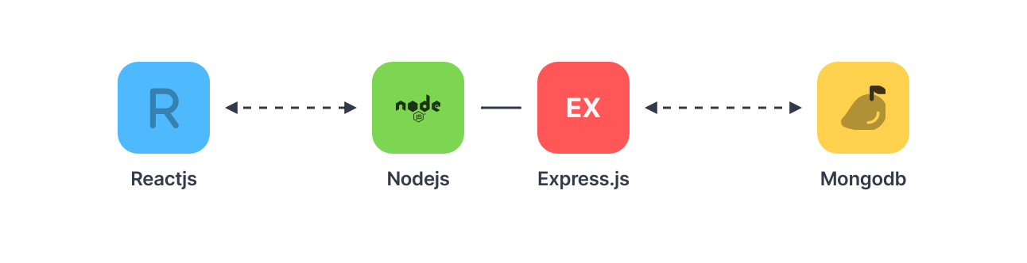

|  |  |
| --- | --- |
| **Components** | **Tech Stack** |
| Frontend | React.js |
| Backend | Node.js, Express.js |
| Database | MongoDB |

1. **SYSTEM FLOWCHART:**

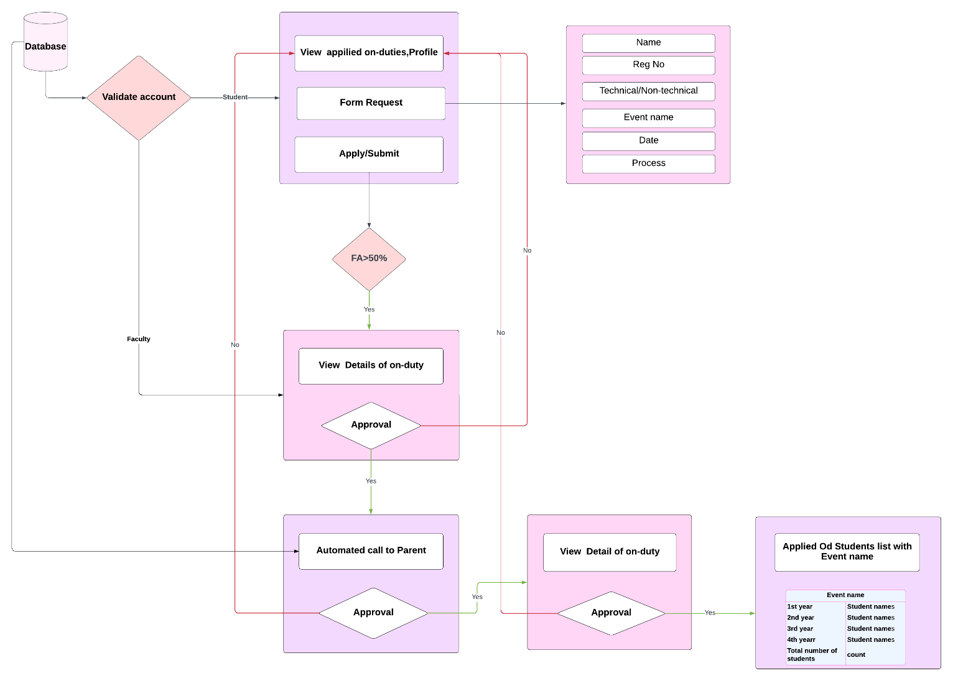

1. 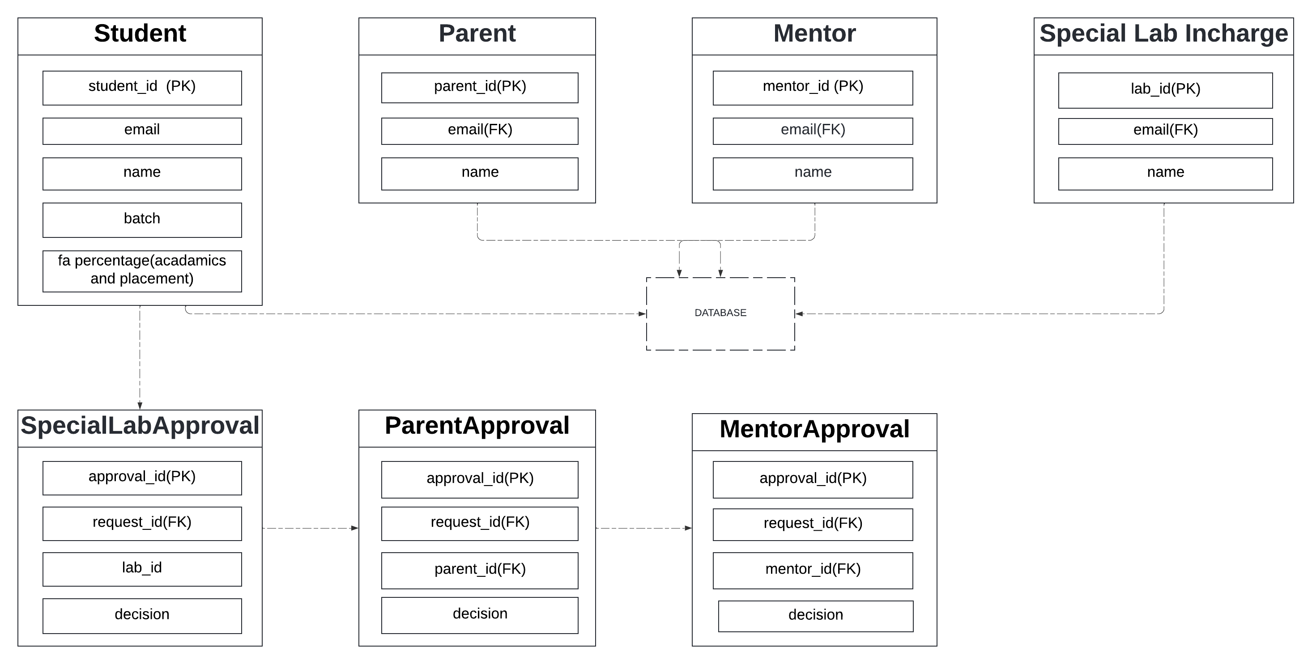**DATABASE:**

**8.SYSTEM WORK FLOW:**